Pathomation LTI plugin for Canvas – installation guide

1. While in the Dashboard page of your canvas website, you select a course

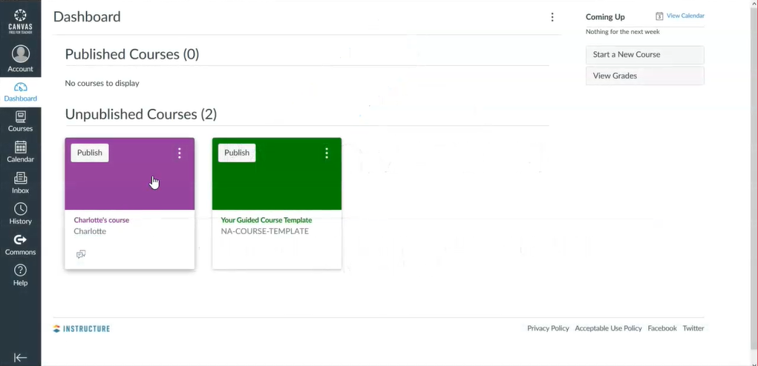

1. Then go to "Settings" and select the "Apps" tab

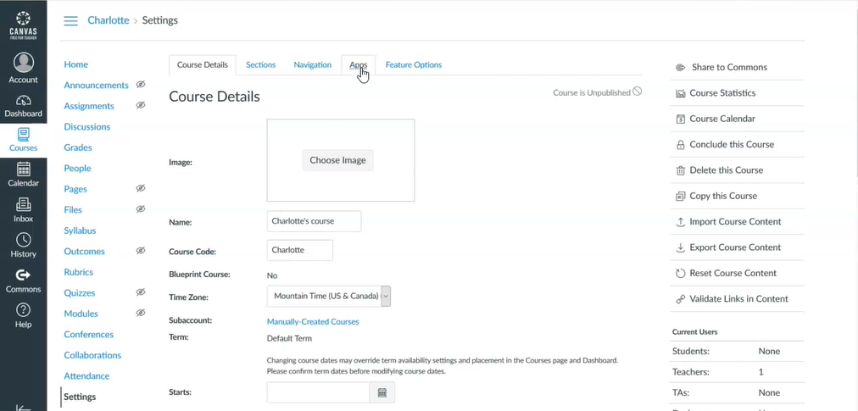

1. Click on "View App Configurations" and then on "+ App" button

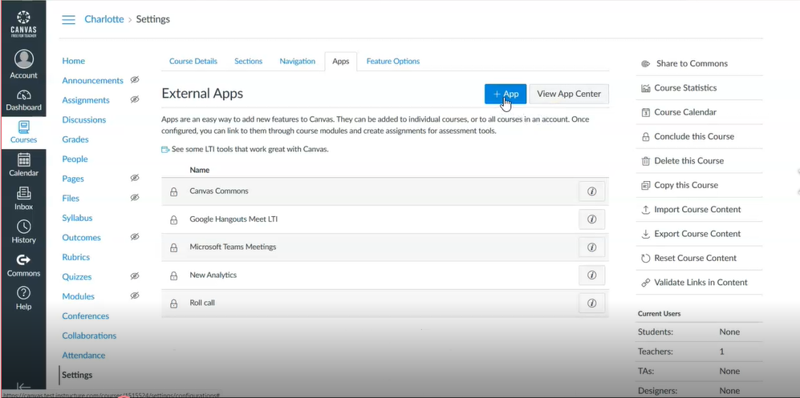

1. Change "Configuration Type" to "Paste XML"

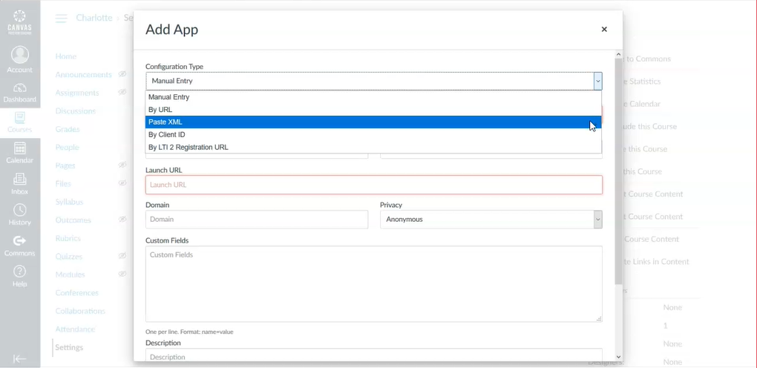

1. Type a name in the "Name" field, for example "PathomationLTI"
2. Go to https://host.pathomation.com/canvas/Settings/ConfigurationXml/27 and copy-paste "Consumer Key", "Secret Key" and "XML configuration" in the corresponding fields

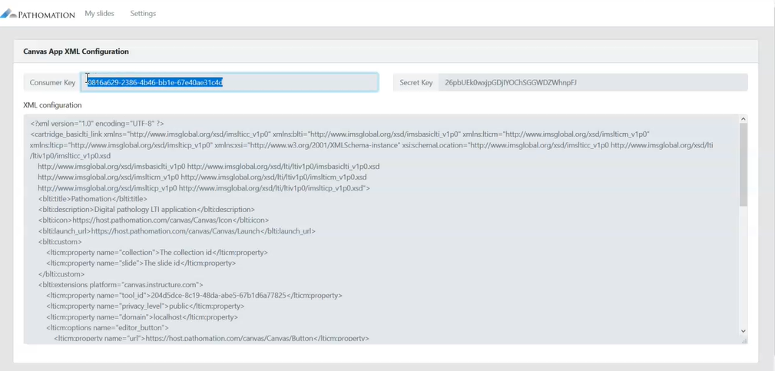

1. Go to your canvas installation and in "Settings" add your PMA.core server or your MyPathomation account. (If you have both, you can connect to both)

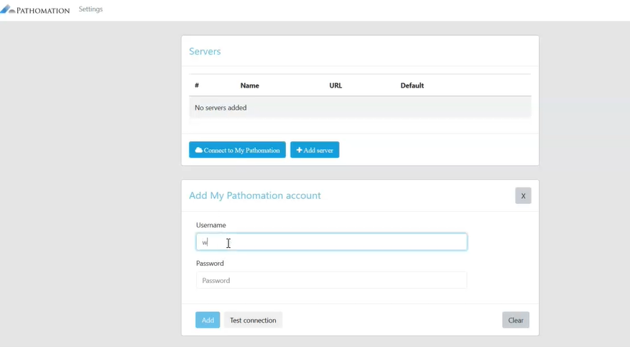

1. Click "Submit" and check that Pathomation app shows in "External Apps" list
2. Click on Pathomation and select a slide if a PMA.core server is selected or even a case or case collection if My Pathomation is selected